DIVE MANAGER

## **User Guide**

Table of Contents

**Introduction 1**

**Launching the Application 2**

**Using the Main Menu** **2**

**LOGIN** 2

**Resourcse Management** 4

Add Services  4

Remove Services  4

View Services  4

Create Containers 4

**Start Container**  4

**Restart Container** 4

**Remove Container** 4

**Commit Container**  4

**Stop Container**  4

**Images** 4

**Project**......................................................................................................................................

**Create Project** 4

**Remove Project** 4

**Predictive Models** 4

**Upload PMML File** 5

**Remove PMML File** 5

**Deploy Model** 7

**Evaluate PMML Models** **8**

**Undeploy Model** 8

**Lamda Models** 9

**Upload Model Diectory** 9

**Create Application** 11

**Train** 12

**Deploy** 14

Evaluate

**Jobs** 15

**Create Job** 15

**Remove Job** 16

**Create Schedule** 16

**Remove Schedule** 18

**Run History** 18

**Users**

**Create Users** 19

**Create Group** 20

**Remove User** 20

**Permission** 26

**Create Permission**  21

**Edit Permission**  22

**Remove Permission** 22

# **Introduction**

Dive Manager is application built using Spring MVC framework.

It helps in performing many

# **Launching the Application**

# 

To launch the application we need to launch browser.

Type the below URL.

<http://dm.dywhin.com:8080/divemanager/login>

Then choose the Menu option to display the required page.

# **Using the Main Menu**

**Choose one of the following options from the main menu:**

Dashboard

Display garfana graphs for memory usage and docker containers/services and images.

Project

Manager Project details.

Predictive Models

Deploying and Evaluating PMML models using open scoring service.

Lambda Models

Handling .

Jobs

Create and scheduling jobs which nifi would pick on schedueled time and runs job.

Users

Handling LDAP user and groups and adding permission to the users.

**[LOGIN](" \l "TOC)**

Dive Manager is authenticated using LDAP. By default we need to have below two groups in LDAP.

1. dn: cn=DIVEMANAGER_USER,ou=groups,dc=dywhin,dc=com

objectClass: groupOfUniqueNames

description: divemanager_user

cn: DIVEMANAGER_USER

uniqueMember: uid=dive_user,ou=users,dc=dywhin,dc=com

1. dn: cn=DIVEMANAGER_ADMIN,ou=groups,dc=dywhin,dc=com

objectClass: groupOfUniqueNames

description: divemanager_admin

cn: DIVEMANAGER_ADMIN

uniqueMember: uid=dive_admin,ou=users,dc=dywhin,dc=com

1. Click on below URL

<http://dm.dywhin.com:8080/divemanager/login>

1. Below page to login credential displayed.

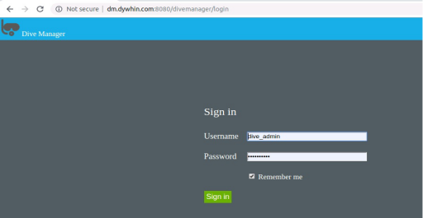

1. Enter Username as dive_admin and password as dive@4275! which is admin account.
2. If success-full login home page of dive manager would be displayed.
3. Depending on user role specific menus would be displayed.

**Resource Management**

**Create Service**

1. Click on Resource Management menu followed by sub menu Services.
2. Services create for the system would be displayed as below

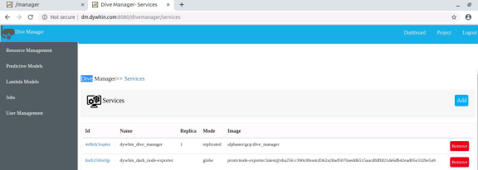

**Figure Services**

**Projects**

We can manage to create/edit/delete project using dive manager.

**Create Project**

1. Click on Projects menu from right side of the menu.
2. A page of already created projects for logged in users are displayed.
3. Click on Add button on the page and the below page is displayed.
4. Enter user defined name for project and click on Save.
5. Required project is created and displayed the projects page.

**Edit Project**

1. Click on Projects menu from right side of the menu.
2. Page of already created projects for logged in users are displayed.
3. Click on project id of the row which we need to edit.
4. Edit project name and click update.
5. Required project is updated and displayed the projects page.

**Remove Project**

1. Click on Projects menu from right side of the menu.
2. Page of already created projects for logged in users are displayed.
3. Click on check boxes of the projects which we need to delete
4. Click on button “Remove”. We get the confirmation box.
5. Selected projects would be removed.

**Predictive Models**

1. Discover a model.
2. Load the data schema information of the selected model. Use this information to initialize bindings with data sources (active fields, group fields) and data sinks (target fields, output fields).
3. Evaluate the selected model with data records.

**Upload PMML File**

1. Click on Menu “Predictive Models” follows sub menu “Build”
2. It would displays page with all the models created by logged in User.
3. Click on Add menu it would display below page.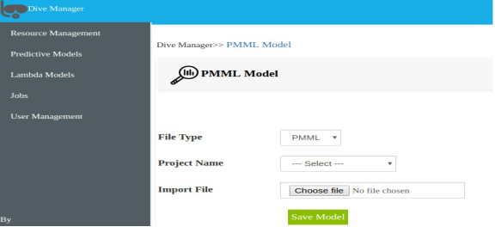

1. Select the Project Name which we need to add this Model.
2. Select the PMML file which needs to be uploaded.
3. Click on Save Model. New PMML Model would be uploaded and displayed in models page

**Remove PMML File**

1. Click on Menu “Predictive Models” follows sub menu “Build”. It would display all models create by logged in users as below.

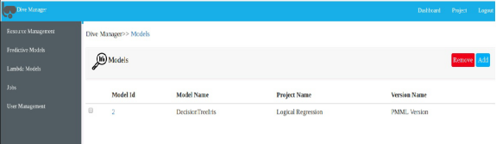

1. It would displays page with all the models created by logged in User.
2. Click on checkbox on each model which we need to remove. Click on “Remove” button.
3. Confirmation box would be displayed. If clicking yes would remove all the PMML models uploaded.

**[Deploy Model](" \l "TOC)**

1. Click on Menu “Predictive Models” follows sub menu “Deploy”.
2. It would display all deployed models create by logged in users as below.

1. 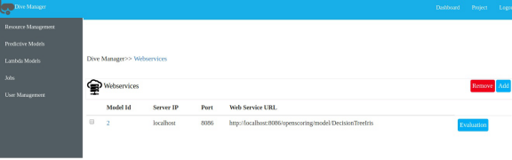

Figure. Deployed PMML Models

1. Click on Add button. We get below page to deploy. We need to select Projects and model which we need to deploy

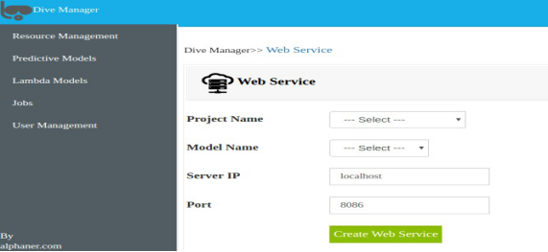

Figure. Deploy PMML Models

1. Click on Create Web Service to deploy.

**Evaluate PMML Models**

1. Click on Menu “Predictive Models” follows sub menu “Deploy”.
2. -It would display all deployed models creates by logged in users shown above as Figure Deployed Models.
3. Click on “Evaluate” button. Below page would be displayed.

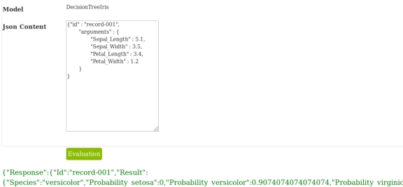

Fiqure. PMML Evaluation

1. We need enter ”**Json Content”**  for the Model as request.
2. Model would be evaluated and Response would be sent back to user with the Result as shown in the above picture.

**[Undeploy Model](" \l "TOC)**

1. Click on Menu “Predictive Models” follows sub menu “Deploy”.
2. It would display all deployed models creates by logged in users shown above as Figure Deployed Models.
3. Select all the check boxes to which we need to Undeploy
4. Click on “Remove” button. Selected models would be undeployed.

# **[Lambda Models](" \l "TOC)**

* Quickly build and deploy an engine as a web service in production with customizable templates
* Respond to dynamic queries in real time once deployed as a web service
* Evaluate and tune multiple engine variants systematically

**Upload Model Directory**

1. Click on Menu “Lambda Models” follows sub menu “upload”.
2. It would display below page to upload Model Client Directory.

1. 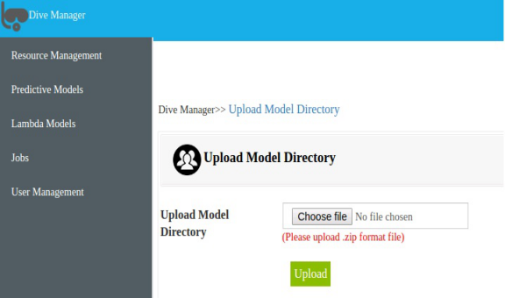
2. **Fiqure Upload Model Directory**

1. We need to zip the directory to upload.
2. For ex. predictionio.text.template.zip
3. Before uploading we need add to Application Name in “**engine.json**” and other parameters if needed as show below as example.

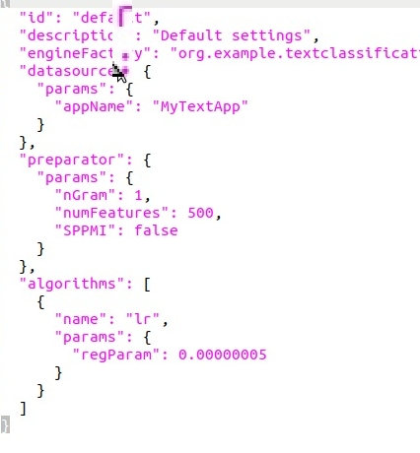

**Fiqure engine.json**

1. Add all the files to import in data folder .
2. Ex

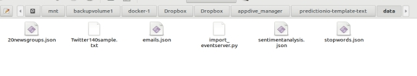

1. Once all changes are done. Click on Upload,
2. On Success Model Directory would be uploaded to server.

**Create Application**

1. Click on Menu “Lambda Models” follows sub menu “build”.
2. It would display application created bu logged in users as below.

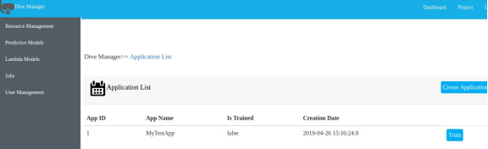

**Fiqure Build**

1. Create on button called “**Create Application**” if we need to create new application. After clicking below page would be displayed.

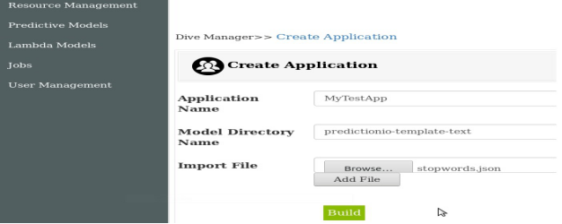

**Fiqure Create Application**

We need enter Application Name which is exactly same as the one which entered in “engine.json” as show in above Fiqure “engin.json”. It should be unique.

1. Enter the model directory name same as the name zipped it while uploading.
2. Import data files to import.
3. File name to import should have same name as we uploaded.
4. Click on **Build.**
5. New application would created and data would be imported and It would build Model Directory.

**Train**

1. Click on Menu “Lambda Models” follows sub menu “build”.
2. It would display application created build list logged in users as shown above in Figure **Build**.
3. Click on **Train** button. Below page would be displayed.

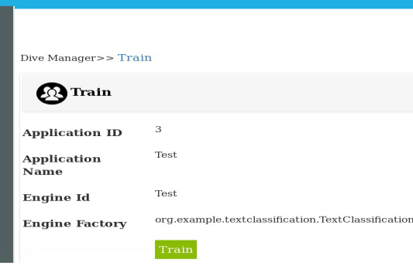

1. It would display the details created during creation of Application.
2. Click on Train and it would start to train a predictive model with training data.
3. Once the training is completed Engine Instance ID would be created and model is ready deploy.

**Deploy**

1. Click on Menu “Lambda Models” follows sub menu “Deploy”.
2. It would display trained applications which are ready deploy shown below which contains Engine Instance ID,Engine ID , Is it trained and Is deployed values.

1. 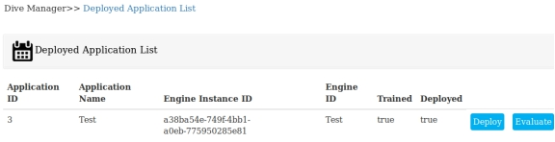

**Figure Deployed Application List**

1. Click **Deploy** button. Below page would be displayed.

1. 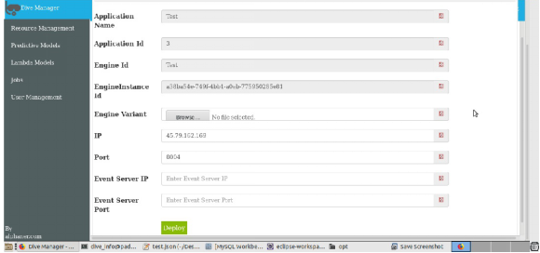

**Figure Deploy**

1. You can also specify the binding IP with --ip, which is set to localhost if not specified. For example: --ip 1.2.3.4

1. By default, deploy deploys an engine on port 8000.

1. You can specify another port with an --port argument. For example, to deploy on port 8123

1. Clicking on Deploy would take the engine as a service.
2. When the engine is deployed successfully and running. You can send query to the engine.

**[Evaluate](" \l "TOC).**

1. Click on Menu “Lambda Models” follows sub menu “Deploy”.
2. It would display applications ready to send the query to engine as shown in the above Figure Deployed Application List.
3. Click on Evaluate button. Below page would be displayed.

1. 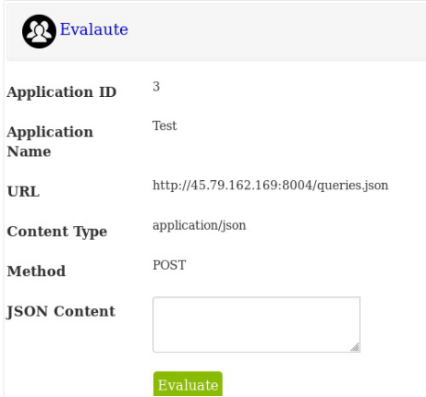

**Figure Evaluation**

1. We would get response as below

{"category":"spam","confidence":0.5268770133242983}

**[JOBS](" \l "TOC)**

Jobs are created by Dive Manager and schedule by corn schedule and same picked by Nifi and run the jobs. After completion of jobs it would enter into runhistory.

**Create Job**

1. Click on Menu “Jobs” follows sub menu “Create Job”.
2. It would display jobs created by logged in user.

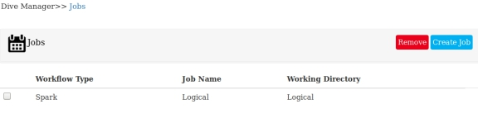

* 1. **Figure Jobs**

1. Click on Create Job button. Below page would be displayed.
   1. 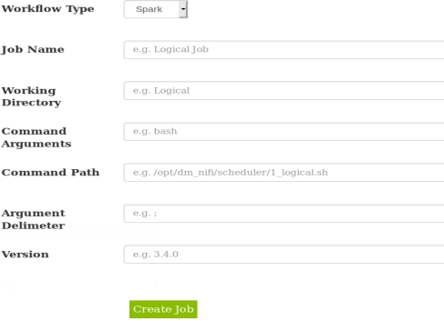
   2. **Figure Create Job**
2. We need to select from Workflow Type which as below three options
   1. Spark
   2. Ii. Shell
   3. iii. Python

* 1. We need to enter our working directory ex “Logical Regression”
  2. Command Arguments would contain arguments like “bash”
  3. After schedule we create shell script in below path
  4. /opt/dm_nifi/scheduler/jobid_jobname.sh. We need to give the path name in Command Path.
  5. Argument delimeter would contain value like “;”.
  6. We need to give verion for the job.

**Remove Jobs**

1. Click on Menu Jobs followed by sub menu Create Job.
2. It would display the page shown above as Fiqure Jobs.
3. Click on checkbox to which the jobs to be deleted.
4. Click on “**Remove**” button. Confirmation box would be dispalyed.
5. On success it would delete all the jobs created.

**Create Scheduler.**

1. Click on Jobs menu and followed by sub menu **Create Scheduler**.
2. It would display all the scheduled jobs created by user show below.

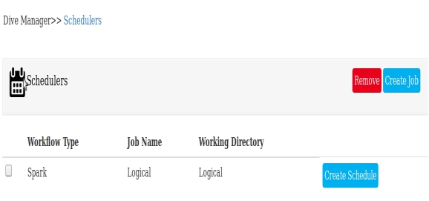**Figure Scheduler**

* 1. Click on **Create Schedule** button**.** It would display below page.

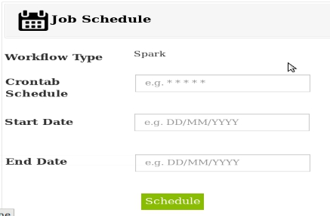

**Figure Job Schedule**

* 1. We need to enter Corntab Schedule for ex “0 1 0 0 0 ”.
  2. Enter Start date and End date.
  3. Once the Schedule completed the shell script with name having jobid_jobname.sh would be created in below path.

**/opt/dm_nifi/scheduler/1_Test.sh**

e. It would have below content

curl -X POST <http://dywhin_nifi:9081/runjob/1_Test>

* 1. On scheduled corntab time nifi would run the job shown below.

**[Remove Scheduler](" \l "TOC)**

1. Click on Menu Jobs followed by sub menu Create Scheduler.
2. It would display the page shown above as Fiqure Schedulers.

c. Click on checkbox to which the jobs to be deleted.

d. Click on “**Remove**” button. Confirmation box would be dispalyed.

e. On success it would delete all the schedulers created

**[Run History](" \l "TOC)**

1. Click on Menu Jobs followed by sub menu Run History.
2. After nifi finishes the job it would enter the Job Run status into Run History.
3. It would be dispalyed by Dive Manager shown below.

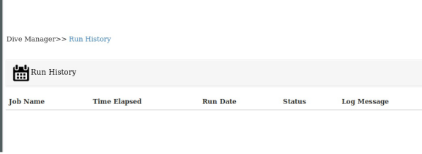

**Figure Run History**

**[Users Management](" \l "TOC)**

Dive Manager login authentication is handled by LDAP. We can manage LDAP using it.

**Create User**

1. Click on Menu User Management and Create User.
2. Users created by logged in users would be displayed shown below.

1. 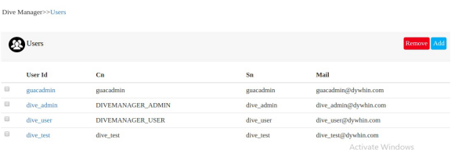

**Figure Users**

1. Click on button Add. Below create user page would be displayed.

1. 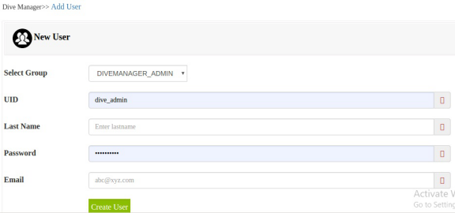

**Figure Create User**

1. We need to select which create group the user would be added.
2. Enter UID or userid, last name ,password and email details.
3. Click on Create User button. User would be created in ldap.

**Remove User/Group**

1. Click on menu User Management followed by sub menu Create User.
2. Users page shown above in Figure Users would be displayed.
3. Click on check box which you want to remove.
4. Click and button Remove. Confirmation box would be displayed.
5. On success selected users would be deleted from ldap.

**Create Group**

1. Click on menu User Management following sub menu Create Group.
2. Below page would be displayed.
   1. 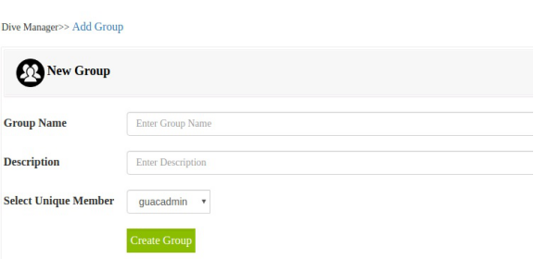
   2. Figure Create Group

1. We need to add group name and description for the same.
2. Select unique member to add to the group. The selection box displays all the users create
3. Click on Create Group button to create group.
4. Group would be create and Figure Users would displayed.

**[Permission](" \l "TOC)**

**Create Permission**

1. Click on User Management menu followed by permission.

1. 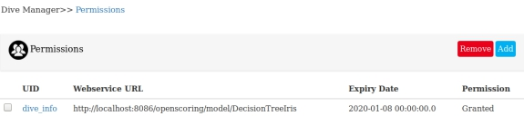

**Figure Permissions**

1. Clicking add button displays below page to add new permission.

1. 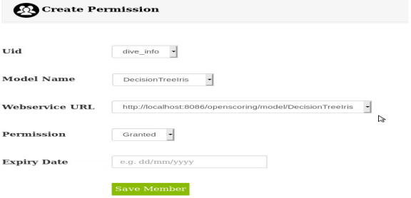

1. **Figure Create Permission**

1. Select User to provide permission to access web service.

1. We need to select which model we need to provide permission to user.

1. Select which Permission we need to give. It has Granted and Denied options.

1. Enter expiry date to the same. Clicking on Save Member would create the permission.

**Edit Permission**

1. Click on menu User Management and submenu Permissions.
2. Permissions created by logged in users displayed show in above figure Permissions
3. Click on Id which has link to edit page to permission shown as below.

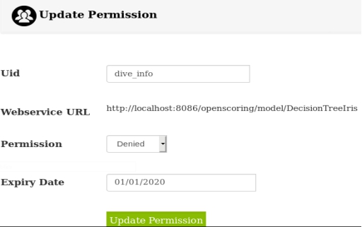

1. We can edit Permission value and click on Update Permission.
2. Permission would be updated successfully.

**[Remove Permission](" \l "TOC)**

1. Click on menu User Management followed by sub menu Permissions
2. Page of permissions created by logged in show in above Figure Permissions.
3. Select on checkboxes which we need delete. Click on Remove button.
4. Confirmation box would be displayed.
5. On success selected permission would be deleted.